import pandas as pd

import numpy as np

from sklearn import tree

from sklearn import preprocessing

titanic_train = pd.read_csv("D:\\ML\\dataset\\train.csv")

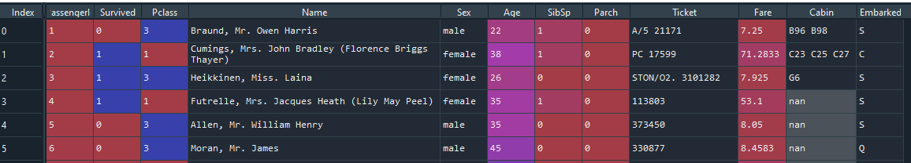

**## to chack the null values**

titanic_train_null = titanic_train.isnull().sum()

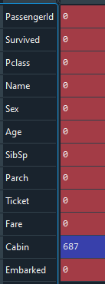

titanic_train['Cabin']=titanic_train['Cabin'].mode()

**####### Mode value to replace cabin columns ## this column is unwanted.**

lable_encoder = preprocessing.LabelEncoder()

encoded_sex = lable_encoder.fit_transform(titanic_train['Sex'])

**####### To change text file to number**

**To Model Creation**

tree_model = tree.DecisionTreeClassifier()

tree_model.fit(X=pd.DataFrame(encoded_sex),y=pd.DataFrame(titanic_train['Survived']))

with open("dtree.dot",'w') as f:

f=tree.export_graphviz(tree_model,feature_names=['Sex'],out_file=f)

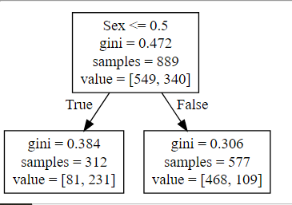

**Add more independent variable**

predictors = pd.DataFrame([encoded_sex,titanic_train['Age'],titanic_train['Pclass'],titanic_train['Fare']]).T

###### To add the more independent variable use T

tree_model = tree.DecisionTreeClassifier(max_depth=8)

###### max_depth = 8 that is idv = 4 and dv values =2 so 4X2 = 8

tree_model.fit(X=predictors,y=titanic_train['Survived'])

with open("Dtree1.dot",'w') as f:

f = tree.export_graphviz(tree_model,feature_names=["Sex","Age","Pclass","Fare"],out_file=f)

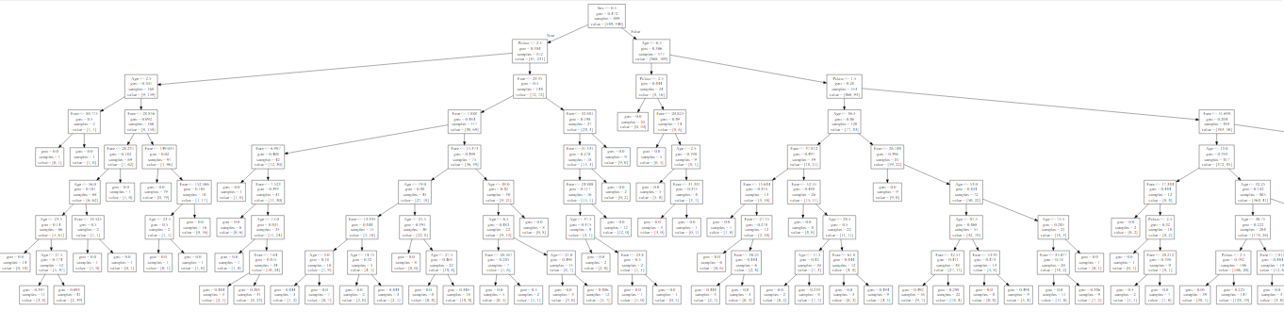

**Model Accuracy**

tree_model.score(X=predictors,y=titanic_train['Survived'])



**Decision Tree helpful for predication**

titanic_test = pd.read_csv("D:\\ML\\dataset\\test.csv")

titanic_test_null = titanic_test.isnull().sum()

encode_sex_test = lable_encoder.fit_transform(titanic_test['Sex'])

**###### Label encoder to change text column to number columns**

test_features = pd.DataFrame([encode_sex_test,titanic_test['Pclass'],titanic_test['Age'],titanic_test['Fare']]).T

#test_preds = tree_model.predict(X=pd.DataFrame([encode_sex_test,titanic_test['Pclass'],titanic_test['Age'],titanic_test['Fare']]))

#predicted_output = pd.DataFrame({"Passenger_ID":titanic_test["PassengerId"],"Survive":test_preds})

# predicted_output.to_csv("output.csv",index=False)

**RandomForestClassifer**

from sklearn.ensemble import RandomForestClassifier

lable_encoder = preprocessing.LabelEncoder()

titanic_train['Sex'] = lable_encoder.fit_transform(titanic_train["Sex"])

titanic_train['Embarked'] = lable_encoder.fit_transform(titanic_train["Embarked"])

rf_model = RandomForestClassifier(n_estimators=1000,max_features=2,oob_score=True)

**###### n_estimatore = 1000 run iteration, max_features = only two split,oob_score = model accuracy**

features = ["Sex","Pclass","SibSp","Age","Fare","Embarked"]

rf_model.fit(X = titanic_train[features],y=titanic_train['Survived'])

print("OOB Accuracy:",rf_model.oob_score_)



**##### To Find important Variable**

for feature,imp in zip(feature,rf_model.feature_importances_):

print(feature,imp)

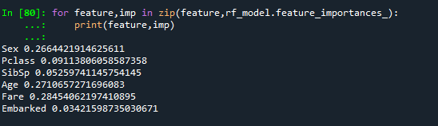

**###### import features are “Sex”,”Age”,”Embarked” it contain higher value’s.**

**Build the Decision Tree**

tree_model = tree.DecisionTreeClassifier()

predictors = pd.DataFrame([encoded_sex,titanic_train['Age'],titanic_train['Fare']]).T

tree_model = tree.DecisionTreeClassifier(max_depth=8)

tree_model.fit(X=predictors,y=titanic_train['Survived'])

with open("Dtree3.dot",'w') as f:

f = tree.export_graphviz(tree_model,feature_names=["Sex","Age","Fare"],out_file=f)

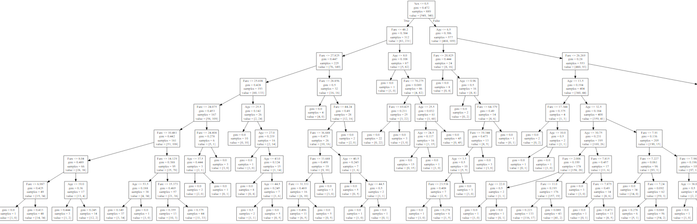

**###### Model Accuracy**

tree_model.score(X=predictors,y=titanic_train['Survived'])



This model is 87% accuracy, so that